1. **INTRODUCTION**

**1.1 Overview**

This project discusses the issue of customer churn, which is the rate at which customers are lost by companies. It is a major concern for large companies, particularly in the telecom industry, due to its direct impact on revenues. Companies are seeking to predict potential churn by analyzing data from previous churns, which may be caused by various reasons such as better price offers, more interesting packages, bad service experiences or change in customers’ personal situations. The project explores the importance of customer churn for companies in the current competitive market and the need for efficient churn predictive models to build cost-effective marketing strategies and prevent losses. The use of machine learning models in the telecom industry to identify probable churn customers and make necessary business decisions is also discussed. The project emphasizes the importance of early identification of customers likely to leave to limit losses and retain customers.

**Key words: Random Forest, flight price prediction, KNN, decision trees.**

**1.2 Purpose**

**Bisiness problem:**

The business problem addressed in this project is the issue of customer churn, which is the rate at which customers are lost by companies, particularly in the telecom industry. The problem is significant as it directly impacts the revenues of companies and is caused by various factors such as better price offers, more interesting packages, bad service experiences or change in customers’ personal situations. Companies are seeking to predict potential churn by analyzing data from previous churns and developing efficient churn predictive models to build cost-effective marketing strategies and prevent losses. The aim is to retain customers and limit the number of customers likely to leave, thereby increasing the company's revenue and maintaining its market position in the face of stiff competition.

telecom industry. It is challenging to predict which customers are likely to leave, as there may be various reasons behind the churn. The reasons could be related to better price offers, more attractive packages from competitors, bad service experiences, or changes in customers' personal situations. As a result, companies need to develop efficient churn predictive models that can analyze data from previous churns and identify patterns and trends that can help predict potential churn.

The development of churn predictive models is crucial for companies as it can help them build cost-effective marketing strategies to retain customers and limit losses. By identifying customers who are likely to leave, companies can tailor their marketing campaigns to target these customers with personalized offers, rewards, or discounts that will encourage them to stay. Additionally, the development of churn predictive models can help companies optimize their marketing budgets by focusing their retention efforts on customers who are most likely to leave.

The ultimate goal of solving the customer churn problem is to increase the company's revenue and maintain its market position in the face of stiff competition. Companies that can retain their customers are more likely to succeed and grow in the long run, as retaining customers is much less expensive than acquiring new ones. Therefore, the development of efficient churn predictive models is essential for companies to stay competitive and achieve their business goals.

* 1. **Business requirement:**

The business requirement for addressing the problem of customer churn is to develop efficient churn predictive models that can analyze customer data and predict potential churn. Companies need to collect customer data such as past purchase history, loyalty program status, demographic information, and service usage patterns to develop personalized pricing and offers that can attract and retain customers.

The churn predictive model should be able to analyze the customer data and identify patterns and trends that are indicative of potential churn. The model should be able to generate accurate predictions and alert the company when customers are at risk of leaving, allowing the company to take timely action to retain the customer.

The churn predictive model should also be scalable, able to analyze large amounts of data quickly, and provide actionable insights to the company. The model should be easy to use and integrate with existing customer relationship management systems, allowing companies to streamline their retention efforts.

Overall, the business requirement for addressing the problem of customer churn is to develop an efficient churn predictive model that can help companies retain customers, build cost-effective marketing strategies, optimize marketing budgets, and ultimately increase revenue and maintain market position

**2.Problem Definition & Design Thinking**

**2.1 Empathy Map**

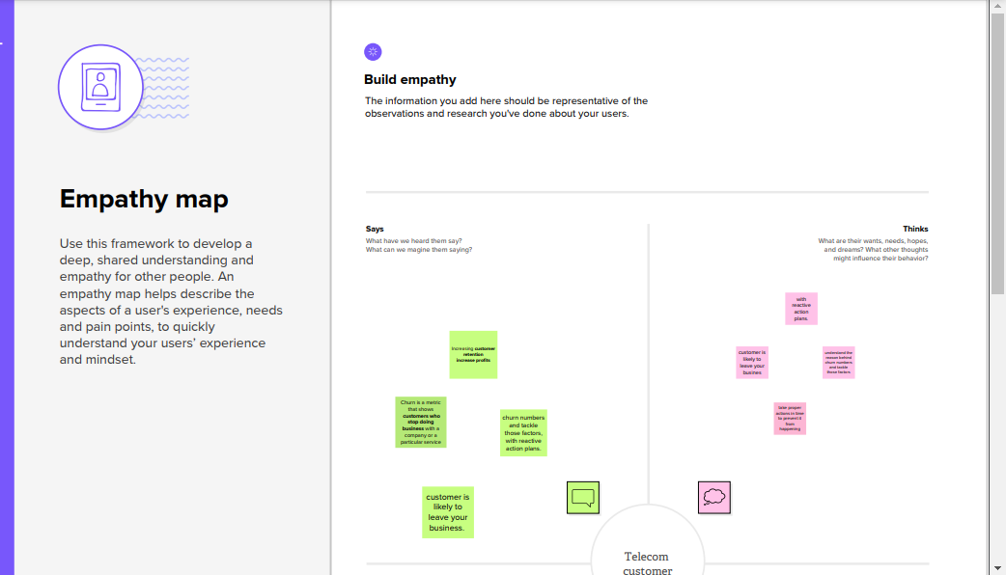

**2.2 Ideation &Brinstorming map**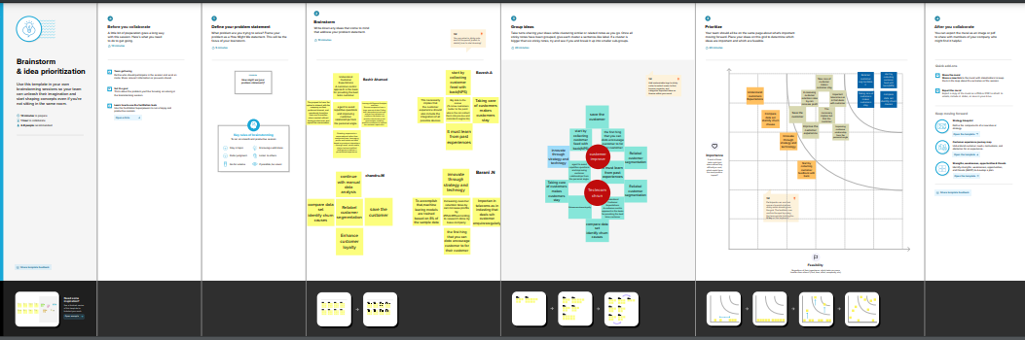

1. **RESULT**

|  | **customerID** | **gender** | **SeniorCitizen** | **Partner** | **Dependents** | **tenure** | **PhoneService** | **MultipleLines** | **InternetService** | **OnlineSecurity** | **...** | **DeviceProtection** | **TechSupport** | **StreamingTV** | **StreamingMovies** | **Contract** | **PaperlessBilling** | **PaymentMethod** | **MonthlyCharges** | **TotalCharges** | **Churn** |
| --- | --- | --- | --- | --- | --- | --- | --- | --- | --- | --- | --- | --- | --- | --- | --- | --- | --- | --- | --- | --- | --- |
| **0** | 7590-VHVEG | Female | 0 | Yes | No | 1 | No | No phone service | DSL | No | ... | No | No | No | No | Month-to-month | Yes | Electronic check | 29.85 | 29.85 | No |
| **1** | 5575-GNVDE | Male | 0 | No | No | 34 | Yes | No | DSL | Yes | ... | Yes | No | No | No | One year | No | Mailed check | 56.95 | 1889.5 | No |
| **2** | 3668-QPYBK | Male | 0 | No | No | 2 | Yes | No | DSL | Yes | ... | No | No | No | No | Month-to-month | Yes | Mailed check | 53.85 | 108.15 | Yes |
| **3** | 7795-CFOCW | Male | 0 | No | No | 45 | No | No phone service | DSL | Yes | ... | Yes | Yes | No | No | One year | No | Bank transfer (automatic) | 42.30 | 1840.75 | No |
| **4** | 9237-HQITU | Female | 0 | No | No | 2 | Yes | No | Fiber optic | No | ... | No | No | No | No | Month-to-month | Yes | Electronic check | 70.70 | 151.65 | Yes |

5 rows × 21 columns

Warning: Total number of columns (21) exceeds max_columns (20) limiting to first (20) columns.

array([['7590-VHVEG', 'Female', 0, ..., 'Yes', 'Electronic check', 29.85], ['5575-GNVDE', 'Male', 0, ..., 'No', 'Mailed check', 56.95], ['3668-QPYBK', 'Male', 0, ..., 'Yes', 'Mailed check', 53.85], ..., ['4801-JZAZL', 'Female', 0, ..., 'Yes', 'Electronic check', 29.6], ['8361-LTMKD', 'Male', 1, ..., 'Yes', 'Mailed check', 74.4], ['3186-AJIEK', 'Male', 0, ..., 'Yes', 'Bank transfer (automatic)', 105.65]], dtype=object)\

|  | **gender** | **SeniorCitizen** | **Partner** | **Dependents** | **tenure** | **PhoneService** | **MultipleLines** | **InternetService** | **OnlineSecurity** | **OnlineBackup** | **DeviceProtection** | **TechSupport** | **StreamingTV** | **StreamingMovies** | **Contract** | **PaperlessBilling** | **PaymentMethod** | **MonthlyCharges** | **TotalCharges** | **Churn** |
| --- | --- | --- | --- | --- | --- | --- | --- | --- | --- | --- | --- | --- | --- | --- | --- | --- | --- | --- | --- | --- |
| **count** | 1152.000000 | 1152.000000 | 1152.000000 | 1152.000000 | 1152.000000 | 1152.000000 | 1152.000000 | 1152.000000 | 1152.000000 | 1152.000000 | 1152.000000 | 1152.000000 | 1152.000000 | 1152.000000 | 1152.000000 | 1152.000000 | 1152.000000 | 1152.000000 | 1152.000000 | 1152.000000 |
| **mean** | 0.510417 | 0.163194 | 0.476562 | 0.310764 | 31.789931 | 0.907986 | 0.942708 | 0.875868 | 0.796007 | 0.886285 | 0.891493 | 0.804688 | 0.988715 | 1.023438 | 0.684028 | 0.592014 | 1.496528 | 66.276476 | 2289.717160 | 0.260417 |
| **std** | 0.500109 | 0.369703 | 0.499667 | 0.463007 | 24.518210 | 0.289171 | 0.951572 | 0.719137 | 0.868936 | 0.885300 | 0.885954 | 0.870930 | 0.892508 | 0.892272 | 0.834209 | 0.491674 | 1.088597 | 29.789613 | 2246.696878 | 0.439053 |
| **min** | 0.000000 | 0.000000 | 0.000000 | 0.000000 | 0.000000 | 0.000000 | 0.000000 | 0.000000 | 0.000000 | 0.000000 | 0.000000 | 0.000000 | 0.000000 | 0.000000 | 0.000000 | 0.000000 | 0.000000 | 18.850000 | 18.850000 | 0.000000 |
| **25%** | 0.000000 | 0.000000 | 0.000000 | 0.000000 | 8.000000 | 1.000000 | 0.000000 | 0.000000 | 0.000000 | 0.000000 | 0.000000 | 0.000000 | 0.000000 | 0.000000 | 0.000000 | 0.000000 | 1.000000 | 41.712500 | 417.687500 | 0.000000 |
| **50%** | 1.000000 | 0.000000 | 0.000000 | 0.000000 | 28.000000 | 1.000000 | 1.000000 | 1.000000 | 0.500000 | 1.000000 | 1.000000 | 1.000000 | 1.000000 | 1.000000 | 0.000000 | 1.000000 | 2.000000 | 73.875000 | 1428.350000 | 0.000000 |
| **75%** | 1.000000 | 0.000000 | 1.000000 | 1.000000 | 55.000000 | 1.000000 | 2.000000 | 1.000000 | 2.000000 | 2.000000 | 2.000000 | 2.000000 | 2.000000 | 2.000000 | 1.000000 | 1.000000 | 2.000000 | 89.937500 | 3815.687500 | 1.000000 |
| **max** | 1.000000 | 1.000000 | 1.000000 | 1.000000 | 72.000000 | 1.000000 | 2.000000 | 2.000000 | 2.000000 | 2.000000 | 2.000000 | 2.000000 | 2.000000 | 2.000000 | 2.000000 | 1.000000 | 3.000000 | 116.250000 | 8476.500000 | 1.000000 |

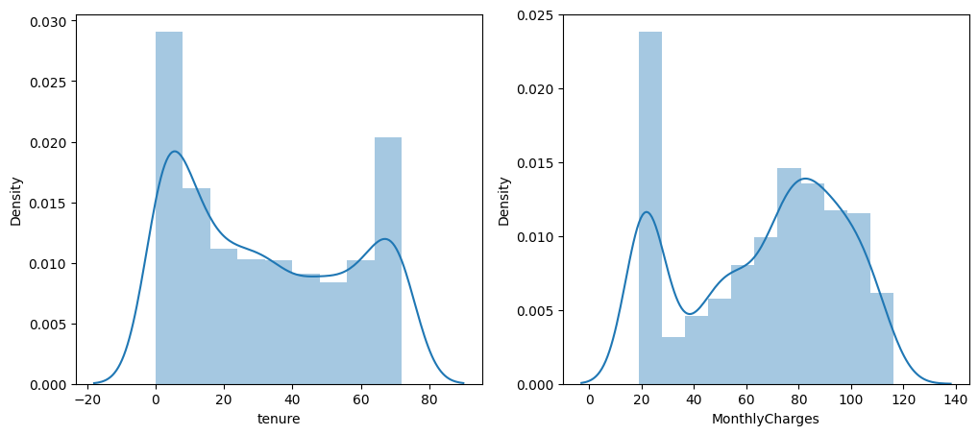

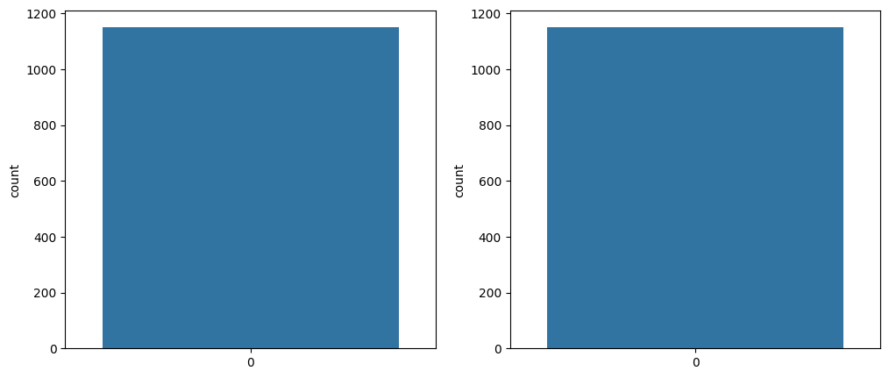

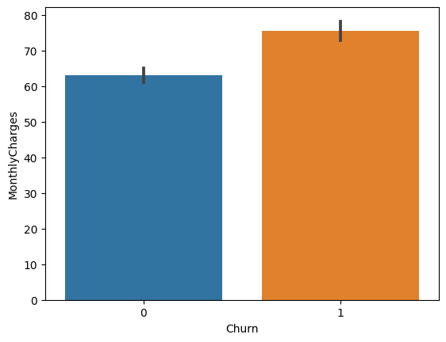

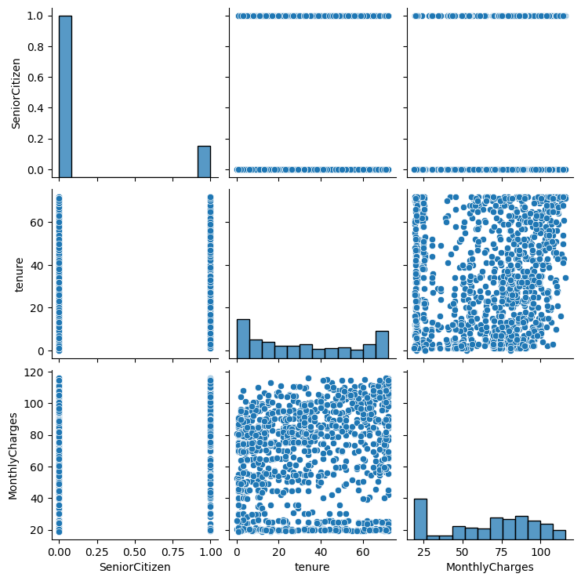

Accuracy Score : 0.8202494497432135

Accuracy Test : 0.7419354838709677

Logistic Regression

Confusion Matrix

[[116 41]

[ 47 137]]

Classification Reprot

precision recall f1-score support

0 0.71 0.74 0.72 157

1 0.77 0.74 0.76 184

accuracy 0.74 341

macro avg 0.74 0.74 0.74 341

weighted avg 0.74 0.74 0.74 341

Accuracy Score : 0.9926632428466617

Accuracy Test : 0.8035190615835777

Random Forest

Confusion Matrix

[[108 49]

[ 18 166]]

Classification Reprot

precision recall f1-score support

0 0.86 0.69 0.76 157

1 0.77 0.90 0.83 184

accuracy 0.80 341

macro avg 0.81 0.80 0.80 341

weighted avg 0.81 0.80 0.80 341

Accuracy Score : 0.8459280997798972

Accuracy Test : 0.7800586510263929

KNN

Confusion Matrix

[[ 98 59]

[ 16 168]]

Classification Reprot

precision recall f1-score support

0 0.86 0.62 0.72 157

1 0.74 0.91 0.82 184

accuracy 0.78 341

macro avg 0.80 0.77 0.77 341

weighted avg 0.80 0.78 0.77 341

Accuracy Score : 0.8459280997798972

Accuracy Test : 0.7800586510263929

SVM

Confusion Matrix

[[ 98 59]

[ 16 168]]

Classification Reprot

precision recall f1-score support

0 0.86 0.62 0.72 157

1 0.74 0.91 0.82 184

accuracy 0.78 341

macro avg 0.80 0.77 0.77 341

weighted avg 0.80 0.78 0.77 341

Accuracy Test : 0.7947214076246334

ANN model

Confusion Matrix

[[129 28]

[ 42 142]]

Classification Reprot

precision recall f1-score support

0 0.75 0.82 0.79 157

1 0.84 0.77 0.80 184

accuracy 0.79 341

macro avg 0.79 0.80 0.79 341

weighted avg 0.80 0.79 0.80 341



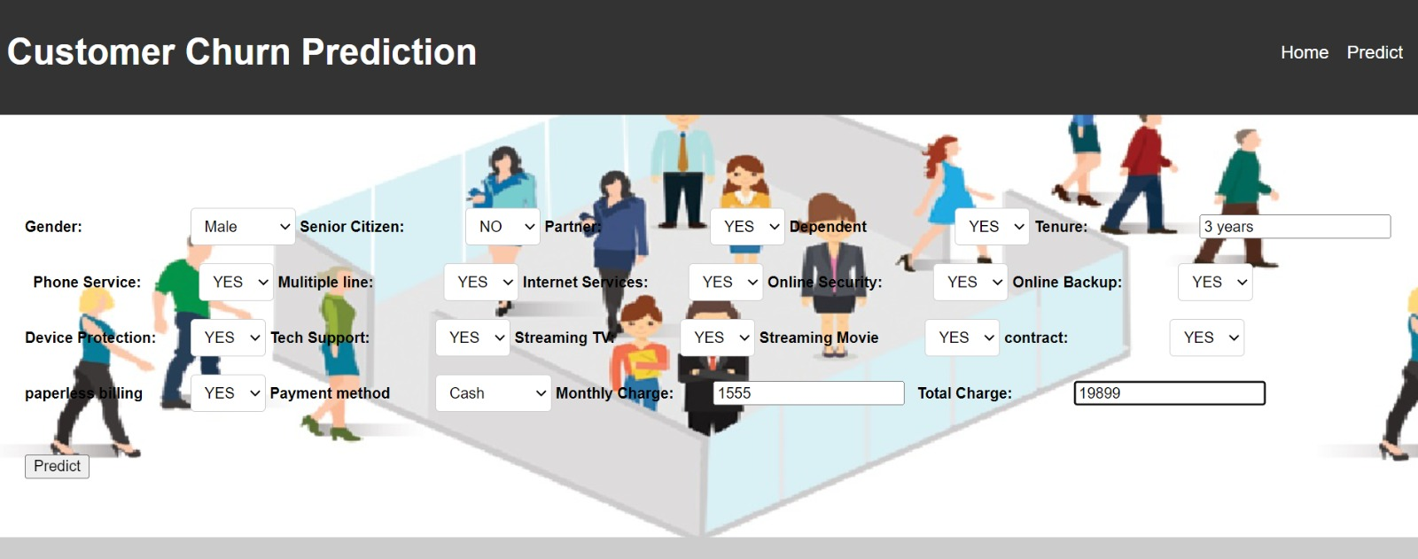

1. **ADVANTAGE AND DISADVANTAGE**

**Advantages**

Increased customer satisfaction: Personalized pricing and offers can enhance the travel experience by providing customers with tailored options that meet their individual needs and preferences.

Improved revenue: Optimized pricing strategies can increase revenue and profitability by maximizing the value of each customer transaction.

Enhanced loyalty: Personalized pricing and offers can help build stronger customer relationships by showing customers that the airline values their business and is willing to provide customized services.

Better marketing: Analyzing customer data can provide airlines with insights into customer behavior and preferences, allowing them to develop targeted marketing campaigns and promotions that engage customers more effectively.

Competitive advantage: By providing personalized pricing and offers, airlines can differentiate themselves from their competitors and improve their market position.

**Disadvantages** of using flight price prediction methods to personalize pricing and offers include:

Privacy concerns: Customers may be hesitant to share personal information with airlines, particularly if they feel that their data is not being used appropriately or ethically.

Accuracy: Predictive models may not always be accurate, and there is a risk of mispricing or misidentifying customer preferences.

Complexity: Developing and implementing a flight price prediction system can be complex and requires significant resources, including expertise in data analytics and machine learning.

Regulatory compliance: The use of customer data is subject to regulatory compliance requirements, which can be complex and time-consuming to navigate.

Customer dissatisfaction: Personalized pricing and offers may not always be perceived as fair or transparent, leading to customer dissatisfaction and potential reputational damage for the airline.

1. **APPLICATION**

Finance: In the finance industry, churn predictive models can help banks and financial institutions identify customers who are likely to close their accounts or stop using their services. This can help banks retain customers by offering them better interest rates, loan terms, or other promotions.

Healthcare: In the healthcare industry, churn predictive models can help insurance companies identify customers who are likely to switch to a different provider or stop paying their premiums. This can help insurance companies retain customers by offering them better coverage or more affordable plans.

Retail: In the retail industry, churn predictive models can help companies identify customers who are likely to stop shopping at their stores or switch to a different brand. This can help companies retain customers by offering them personalized promotions, loyalty rewards, or other incentives.

Subscription services: Churn predictive models are especially useful for subscription-based services, such as streaming platforms or software-as-a-service (SaaS) companies. These models can help companies identify customers who are likely to cancel their subscriptions and offer them personalized deals or incentives to stay subscribed.

1. **CONCLUSION**
2. In conclusion, churn predictive modeling is a powerful tool that can help companies identify and retain their most valuable customers. By analyzing customer data and predicting potential churn, companies can take proactive measures to retain customers, optimize their marketing strategies, and gain a competitive advantage. Churn predictive models can help companies build cost-effective retention strategies that are tailored to individual customers, resulting in higher customer satisfaction, lower customer acquisition costs, and increased revenues.
3. **FUTURE SCOPE**

In the future, churn predictive modeling is expected to become even more sophisticated and accurate, as companies continue to gather and analyze larger amounts of customer data. Machine learning algorithms and artificial intelligence will play an increasingly important role in churn prediction, allowing companies to make more precise and personalized predictions. Additionally, as more industries move towards subscription-based business models, churn predictive models will become even more essential for retaining customers and ensuring long-term business success. Companies will need to stay ahead of the curve by investing in advanced analytics tools, data management systems, and machine learning technologies to stay competitive in a rapidly evolving business landscape.

1. **APPANDIX**

**CODE**

import pandas as pd

import numpy as np

import pickle

from  google.colab import files

import io

import matplotlib.pyplot as plt

%matplotlib inline

import seaborn as sns

import sklearn

from sklearn.preprocessing import LabelEncoder,OneHotEncoder

from sklearn.linear_model import LogisticRegression

from sklearn.tree import DecisionTreeClassifier

from sklearn.ensemble import RandomForestClassifier

from sklearn.neighbors import KNeighborsClassifier

from sklearn.svm import SVC

from sklearn.model_selection import RandomizedSearchCV

import imblearn

from imblearn.over_sampling import SMOTE

from sklearn.model_selection import train_test_split

from sklearn.preprocessing import StandardScaler

from sklearn.metrics import accuracy_score, classification_report, confusion_matrix, f1_score

data=files.upload()

data=pd.read_csv("/content/WA_Fn-UseC_-Telco-Customer-Churn.csv")

df=data

data

data = data.iloc[:,1:]

data.info()

data.TotalCharges.fillna(data.TotalCharges.mean(), inplace=True)

data.isnull().sum()

data.head()

x=data.iloc[:,0:19].values

y=data.iloc[:,19:20].values

x

y

from sklearn.preprocessing import OneHotEncoder

one=OneHotEncoder()

a=one.fit_transform(x[:,6:7]).toarray()

b=one.fit_transform(x[:,7:8]).toarray()

c=one.fit_transform(x[:,8:9]).toarray()

d=one.fit_transform(x[:,9:10]).toarray()

e=one.fit_transform(x[:,10:11]).toarray()

f=one.fit_transform(x[:,11:12]).toarray()

g=one.fit_transform(x[:,12:13]).toarray()

h=one.fit_transform(x[:,13:14]).toarray()

i=one.fit_transform(x[:,14:15]).toarray()

j=one.fit_transform(x[:,16:17]).toarray()

x=np.delete(x,[6,7,8,9,10,11,12,13,14,16],axis=1)

x=np.concatenate((a,b,c,d,e,f,g,h,i,j,x),axis=1)

x

y

from imblearn.over_sampling import SMOTE

sm = SMOTE()

x_resampled, y_resampled = sm.fit_resample(x, y)

x_resampled

y_resampled

x.shape,x_resampled.shape

y.shape,y_resampled.shape

data.describe()

plt.figure(figsize=(12,5))

plt.subplot(1,2,1)

sns.distplot(data["tenure"])

plt.subplot(1,2,2)

sns.distplot(data["MonthlyCharges"])

plt.figure(figsize=(12,5))

plt.subplot(1,2,1)

sns.countplot(data["gender"])

plt.subplot(1,2,2)

sns.countplot(data["Dependents"])

sns.barplot(x="Churn",y="MonthlyCharges",data=data)

sns.heatmap(df.corr(),annot=True)

sns.pairplot(data=df,markers=["^","v"],palette="inferno")

from sklearn.preprocessing import StandardScaler

sc=StandardScaler()

x_train=sc.fit_transform(x_train)

x_test=sc.fit_transform(x_test)

x_train.shape

def logreg(x_train,x_test,y_train,y_test):

  lr=LogisticRegression(random_state=0)

  lr.fit(x_train,y_train)

  ylt=lr.predict(x_train)

  print("Accuracy Score :",accuracy_score(ylt,y_train))

  yPred_lr=lr.predict(x_test)

  print("Accuracy Test :",accuracy_score(yPred_lr,y_test))

  print("Logistic Regression")

  print("Confusion Matrix")

  print(confusion_matrix(y_test, yPred_lr))

  print("Classification Reprot")

  print(classification_report(y_test, yPred_lr))

logreg(x_train,x_test,y_train,y_test)

import keras

from keras.models import Sequential

from keras.layers import Dense

classifier=Sequential()

classifier.add(Dense(units=30, activation="relu",input_dim=40))

classifier.add(Dense(units=30, activation="relu"))

classifier.add(Dense(units=1, activation="sigmoid"))

classifier.compile(optimizer="adam",loss="binary_crossentropy",metrics=['accuracy'])

def dTree(x_train,x_test,y_train,y_test):

  dtc=DecisionTreeClassifier(criterion="entropy",random_state=0)

  dtc.fit(x_train,y_train)

  y_dt_tr=dtc.predict(x_train)

  print("Accuracy Score :",accuracy_score(y_dt_tr,y_train))

  yPred_dt=dtc.predict(x_test)

  print("Accuracy Test :",accuracy_score(yPred_dt,y_test))

  print("Decsion Tree")

  print("Confusion Matrix")

  print(confusion_matrix(y_test, yPred_dt))

  print("Classification Reprot")

  print(classification_report(y_test, yPred_dt))

dTree(x_train,x_test,y_train,y_test)

def RandomForest(x_train,x_test,y_train,y_test):

  rf=RandomForestClassifier(criterion="entropy",n_estimators=10,random_state=0)

  rf.fit(x_train,y_train)

  y_rf_tr=rf.predict(x_train)

  print("Accuracy Score :",accuracy_score(y_rf_tr,y_train))

  yPred_rf=rf.predict(x_test)

  print("Accuracy Test :",accuracy_score(yPred_rf,y_test))

  print("Random Forest")

  print("Confusion Matrix")

  print(confusion_matrix(y_test, yPred_rf))

  print("Classification Reprot")

  print(classification_report(y_test, yPred_rf))

RandomForest(x_train,x_test,y_train,y_test)

def KNN(x_train,x_test,y_train,y_test):

  knn=KNeighborsClassifier()

  knn.fit(x_train,y_train)

  y_knn_tr=knn.predict(x_train)

  print("Accuracy Score :",accuracy_score(y_knn_tr,y_train))

  yPred_knn=knn.predict(x_test)

  print("Accuracy Test :",accuracy_score(yPred_knn,y_test))

  print("KNN")

  print("Confusion Matrix")

  print(confusion_matrix(y_test, yPred_knn))

  print("Classification Reprot")

  print(classification_report(y_test, yPred_knn))

KNN(x_train,x_test,y_train,y_test)

def SVM(x_train,x_test,y_train,y_test):

  svm=KNeighborsClassifier()

  svm.fit(x_train,y_train)

  y_svm_tr=svm.predict(x_train)

  print("Accuracy Score :",accuracy_score(y_svm_tr,y_train))

  yPred_svm=svm.predict(x_test)

  print("Accuracy Test :",accuracy_score(yPred_svm,y_test))

  print("SVM")

  print("Confusion Matrix")

  print(confusion_matrix(y_test, yPred_svm))

  print("Classification Reprot")

  print(classification_report(y_test, yPred_svm))

SVM(x_train,x_test,y_train,y_test)

import keras

from keras.models import Sequential

from keras.layers import Dense

classifier=Sequential()

classifier.add(Dense(units=30, activation="relu",input_dim=40))

classifier.add(Dense(units=30, activation="relu"))

classifier.add(Dense(units=1, activation="sigmoid"))

classifier.compile(optimizer="adam",loss="binary_crossentropy",metrics=['accuracy'])

model_histroty=classifier.fit(x_train,y_train, batch_size=10, validation_split=0.33,epochs=200

ann_pred=classifier.predict(x_test)

ann_pred=(ann_pred>0.5)

ann_pred

print("Accuracy Test :",accuracy_score(ann_pred,y_test))

print("ANN model")

print("Confusion Matrix")

print(confusion_matrix(y_test, ann_pred))

print("Classification Reprot")

print(classification_report(y_test, ann_pred))

lr=LogisticRegression(random_state=0)

lr.fit(x_train,y_train)

print("Predicting on random input")

lr_pred_own=lr.predict(sc.transform([[0,0,1,1,0,0,0,0,1,0,0,1,0,0,1,0,0,1,0,0,1,0,0,1,0,0,1,0,1,0,0,1,1,0,0,456,1,0,3245,4567]]))

print("output is :", lr_pred_own)

dtc=DecisionTreeClassifier(criterion="entropy",random_state=0)

dtc.fit(x_train,y_train)

print("Predicting on random input")

dtc_pred_own=dtc.predict(sc.transform([[0,0,1,1,0,0,0,0,1,0,0,1,0,0,1,0,0,1,0,0,1,0,0,1,0,0,1,0,1,0,0,1,1,0,0,456,1,0,3245,4567]]))

print("output is :", dtc_pred_own)

print("Predicting on random input")

ann_pred_own=classifier.predict(sc.transform([[0,0,1,1,0,0,0,0,1,0,0,1,0,0,1,0,0,1,0,0,1,0,0,1,0,0,1,0,1,0,0,1,1,0,0,456,1,0,3245,4567]]))

ann_pred_own=(ann_pred_own>0.5)

print("output is :", ann_pred_own)

svc=SVC(kernel="linear")

svc.fit(x_train,y_train)

print("Predicting on random input")

svm_pred_own=svc.predict(sc.transform([[0,0,1,1,0,0,0,0,1,0,0,1,0,0,1,0,0,1,0,0,1,0,0,1,0,0,1,0,1,0,0,1,1,0,0,456,1,0,3245,4567]]))

print("output is :", svm_pred_own)

knn=KNeighborsClassifier()

knn.fit(x_train,y_train)

print("Predicting on random input")

knn_pred_own=knn.predict(sc.transform([[0,0,1,1,0,0,0,0,1,0,0,1,0,0,1,0,0,1,0,0,1,0,0,1,0,0,1,0,1,0,0,1,1,0,0,456,1,0,3245,4567]]))

print("output is :", knn_pred_own)

print("Predicting on random input")

ann_pred_own=classifier.predict(sc.transform([[0,0,1,1,0,0,0,0,1,0,0,1,0,0,1,0,0,1,0,0,1,0,0,1,0,0,1,0,1,0,0,1,1,0,0,456,1,0,3245,4567]]))

print(ann_pred_own)

ann_pred_own=(ann_pred_own>0.5)

print("output is :", ann_pred_own)

def comp_mod(x_train,x_test,y_train,y_test):

  logreg(x_train,x_test,y_train,y_test)

  print("-"*100)

  dTree(x_train,x_test,y_train,y_test)

  print("-"*100)

  RandomForest(x_train,x_test,y_train,y_test)

  print("-"*100)

  SVM(x_train,x_test,y_train,y_test)

  print("-"*100)

  KNN(x_train,x_test,y_train,y_test)

  print("-"*100)

model = RandomForestClassifier()

model.fit(x_train, y_train)

y_rf=model.predict(x_train)

print(accuracy_score(y_rf,y_train))

y_pred_rcv=model.predict(x_test)

print(accuracy_score(y_pred_rcv,y_test))

print("**Random Forest after Hyperparameter tuning**")

print("Confusion Matrix")

print(confusion_matrix(y_test, y_pred_rcv))

print("Classification Reprot")

print(classification_report(y_test, y_pred_rcv))

print("Predicting on random input")

rfcv_pred_own=model.predict(sc.transform([[0,0,1,1,0,0,0,0,1,0,0,1,0,0,1,0,0,1,0,0,1,0,0,1,0,0,1,0,1,0,0,1,1,0,0,456,1,0,3245,4567]]))

print("output is :", rfcv_pred_own)

from flask import Flask, render_template, request

import keras

from keras.models import load_model

app = Flask(__name__)

model = load_model("/content/telecom_churn.h5")

 if (a == 'f'):

        a = 0

    elif (a == 'm'):

        a = 1

    b = request.form["srcitizen"]

    if (b == 'n'):

        b = 0

    elif (b == 'y'):

        n = 1

    c = request.form["srcitizen"]

    if (c == 'n'):

        c = 0

    elif (c == 'n'):

        c = 1

    d = request.form["dependents"]

    if (d == 'n'):

        d = 0

    elif (d == 'n'):

**FLASK CODING**

!pip install flask-ngrok

!pip install pyngrok==4.1.1

!pip install flask_ngrok

from google.colab import drive

drive.mount('/content/drive')

!ngrok authtoken "2OBqSJ6TTJQEjqPWIceq38LQj7W_2BmBaC16VDx6dJZG3ERM1" #Without "" marks

from flask_ngrok import run_with_ngrok

from flask import Flask, render_template

app = Flask(__name__)

run_with_ngrok(app)

@app.route('/')

def text():

  return f"Running Flask on Google Colab"

app.run()

from flask import Flask, render_template, request

import numpy as np

import pickle

import pandas as pd

model=pickle.load(open ("/content/sample_data/model1.pkl",'rb'))

app = Flask (__name__)

@app.route("/")

def home():

  return render_template('/content/Flask/home.html')

@app.route("/content/Flask/predict.html")

def pred():

  return render_template('/content/Flask/predict.html')

@app.route("/pred", methods=['POST', 'GET'])

def predict():

  x = [[int(x) for x in request.form.values()]]

  print(x)

  x = np.array(x)

  print(x.shape)

  print (x)

  pred = model.predict(x)

  print (pred[0])

  return render_template('/content/Flask/submit.html', prediction_text=pred[0])

if __name__ == "__main__":

  !ngrok authtoken "2OBqSJ6TTJQEjqPWIceq38LQj7W_2BmBaC16VDx6dJZG3ERM1" #Without "" marks

from flask import Flask, render_template

app = Flask(__name__)

run_with_ngrok(app)

@app.route('/')

def hello():

    return render_template('/content/sample_data/index.html', utc_dt=datetime.datetime.utcnow())

app.run()

from flask import Flask, render_template, request

import numpy as np

import pickle

import pandas as pd

model=pickle.load(open ("/content/sample_data/model1.pkl",'rb'))

app = Flask (__name__)

@app.route("/")

def home():

  return render_template('/content/Flask/home.html')

@app.route("/content/Flask/predict.html")

def pred():

  return render_template('/content/Flask/predict.html')

@app.route("/pred", methods=['POST', 'GET'])

def predict():

  x = [[int(x) for x in request.form.values()]]

  print(x)

  x = np.array(x)

  print(x.shape)

  print (x)

  pred = model.predict(x)

  print (pred[0])

  return render_template('/content/Flask/submit.html', prediction_text=pred[0])

if __name__ == "__main__":

  !ngrok authtoken "2OBqSJ6TTJQEjqPWIceq38LQj7W_2BmBaC16VDx6dJZG3ERM1" #Without "" marks

from flask import Flask, render_template

app = Flask(__name__)

run_with_ngrok(app)

@app.route('/')

def hello():

    return render_template('/content/sample_data/index.html', utc_dt=datetime.datetime.utcnow())

app.run()